**SUBJECT INSTRUCTIONS**

“SHAPES AND SHOCKS” EXPERIMENT

**I. INTRODUCTION TO THE EXPERIMENT**________________________________________

This experiment is interested in attention and learning. You are going to be asked to play several mini attention and learning games on the computer, and at the end of the experiment you will be asked to compete some questionnaires. The learning task will consist of learning the relationship between shapes and electric shocks (at the level that you chose before beginning this part of the task). The attention tasks will be fast-paced thinking and perceptual games. Each of these tasks will be described in detail later in the experiment, and you will have a chance to practice each one before the Main Phase – where all these tasks will be presented together.

Any questions before we start?

**II. RATING PRACTICE**_____________________________________

You will now practice using the ratings that you will use in the Main Phase. Here, you will see a shape and be asked 3 different questions. (*In the Main Phase, a shape will be linked with a shock – so these ratings will make more sense in the Main Phase.*) You can provide your response using the numbers on the keyboard. The questions will ask how much you **EXPECT** the electric shock to occur, how **POSITIVE / NEGATIVE** you feel, and how **TENSE / CALM** you feel. They will look like this:

POSITVE / NEGATIVE RATINGS

Using the numbered scale, rate how **positive or negative** you feel, ranging from feeling pleasant/happy [1] to feeling unpleasant/unhappy [9].

TENSE / CALM RATINGS

Using the numbered scale, rate how **tense or calm** you feel, ranging from strong tenseness/arousal [1] to very calm/bored [9].

Select the number that represents your emotions best. You can also select the space in between two pictures.

Your job is to respond as accurately and as honestly as possible, without taking too much time to think about it.

You will complete each of these ratings for three different shapes.

It is important to know that your answers to neither rating scale **DO NOT** influence the likelihood of the shock occurring with any shape. Your answers are completely independent of the stimuli presented throughout the task.

**1. ELECTRIC SHOCK RATING**_____________________________________

The learning task in the Main Phase will consist of learning the relationship between shapes and shocks. Specifically, one shape will be linked with a shock, and the other shape will not be. Your job will be to figure out which shape is linked with the shocks. Before we start, we want to get the same emotion ratings for the shock.

You will receive an electric shock, followed by the same emotion ratings you just practiced. As before, rate how **positive or negative**, and **tense or calm** you feel in the moment.

how strong is your fear?

**1. (B) PRACTICE PHASE: “dots” TASK**__________________________________________

We will now practice one of the “attention” tasks. At some points during the experiment, you will see a circle of fast-moving dots on the screen. Your job is to decide whether most of the dots are moving to the left (1 key) or to the right (2 key) as below.

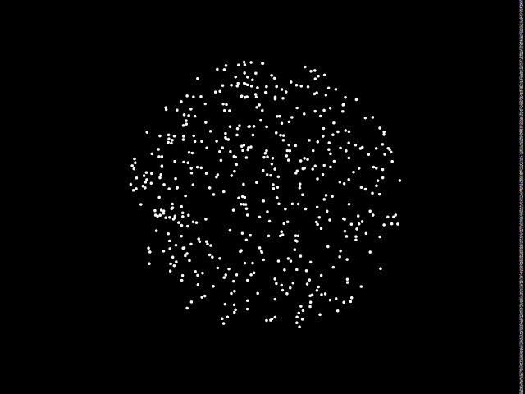

You will only have a couple of seconds to respond, so you should also try to make these responses as quickly as possible whilst being as accurate as possible. You will have to make a number of these judgements in a row.

**1. (C) PRACTICE PHASE: “seen before?” TASK**_______________________________

We will now practice the other “attention” task. For these tasks, you will see a photograph of an object with a background (e.g., a laptop on a desk). Your job is to answer (“yes” or “no”) as to whether you think you have come across a similar object-background scene before in your day-to-day life. Your response should be accurate and timely, as you will only have a few seconds to respond. These “seen before” tasks will appear as below:

**2. MAIN PHASE**_________________________________________________

Now that you have finished practicing all the tasks, the Main Phase will combine all these tasks together.

As mentioned, the main “learning” task of the Main Phase involves figuring out the relationship between shapes and shocks. These shapes will be squares and circles, as below:

You must keep both your eyes and attention focused on the stimuli for as long as they remain on the screen. Importantly, one of these shapes will be ***sometimes linked with a shock***, whereas the other shape will ***never be.*** Your job is to learn which shape is linked with the shock. This pattern will not change throughout the experiment; That is, if one shape is linked with the shock, it *always will* - and the *other* shape *never will* - throughout the whole experiment.

This main “learning task” will occur with the other “attention tasks” interspersed throughout the Main Phase. For example, you may see: a shape (with or without a shock), followed by a set of “dot” tasks, then followed by a “seen before?” task, then followed by a shape (with or without a shock), etc. After some trials, you will be asked to complete ratings on how your expectation of the shock, how positive/negative and how tense/calm you feel.

Your job is to complete all of these “attention” and “learning tasks” as THOUGHTFULLY and ACCURATELY as possible, including paying attention to and learning which shape predicts the shocks. This phase will last approximately 15-20 minutes.

**3. TEST PHASE**

We are now going to test your memory for the objects from the photographs you saw in the previous phase (i.e., from the “seen before?” trials). We want you to try your best to recall what CENTRAL OBJECT appeared against that background previously and name that object out oud. You will be given up to 15 seconds to make your response. Feel free to guess if you can’t remember for sure. Click the mouse to move to the next photograph.

For example, you might see a background setting like this:

In this example, you’d want to say clearly “laptop” for the experimenter to jot down.